Moodle 2 Student Quick Start Guide

Logging In 2
Customizing the Home Page of Moodle 4
View Assignments and Forums in the Course Overview Block 8
Navigating in Your Moodle Class 9
Using Blocks 10
Configuring Your Profile 15
Submitting an Assignment 17
Participating in a Discussion Group (Advanced Forum) 23
Getting Help 27

Logging In
Important: If you run Moodle through a browser other than Firefox, the system may not operate correctly. If you don’t have Firefox, download it here for free: http://www.mozilla.org/en-US/firefox/fx/

Task | Screen Shot
- Open your Firefox browser.  - Type the following in the address bar: http://moodle.alverno.edu/  - Press the Enter key. | 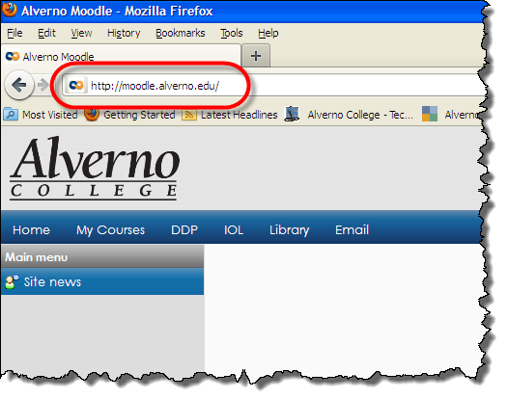
- Type your Alverno username and password.  - Click the Login button. | 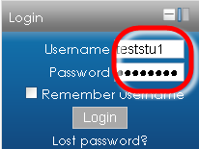
- In the right column on the page, find the Courses Available to You block.  - Click the + sign next to Semester Courses. | 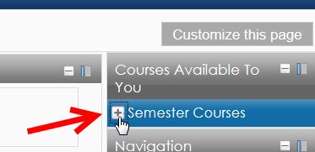
- Click the + sign next to the current semester. | 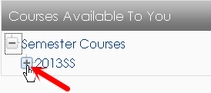
- Click the name of the course you want to enter.  Important: If you do not see a course you registered for, it may have been hidden by your instructor while she or he is working on the course. When the instructor is done setting up the course, it will appear in your course list. | 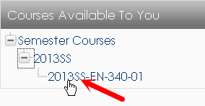

Customizing the Home Page of Moodle
Use the following instructions to customize the home page of Moodle.

Task | Screen Shot
- Log in to Moodle.  Your home page appears.  - Once you log into Moodle, you can determine which courses appear in the center Course Overview block. | 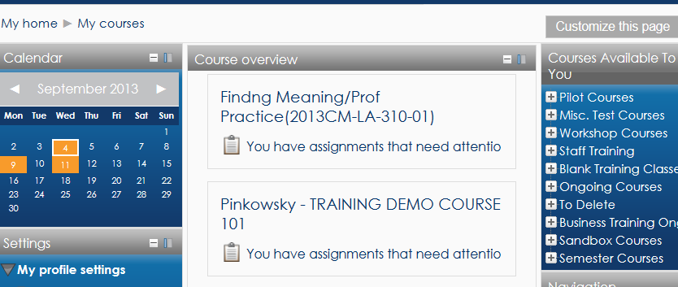
- On the top right of the page, click the Customize this Page button.  - Notice that each block now displays a set of icons in its top right corner. | 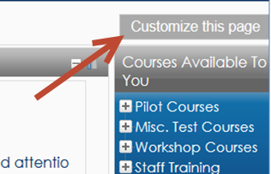
- In the Number of Courses to Display field, select Always Show All.  Moodle will now display all your courses. | 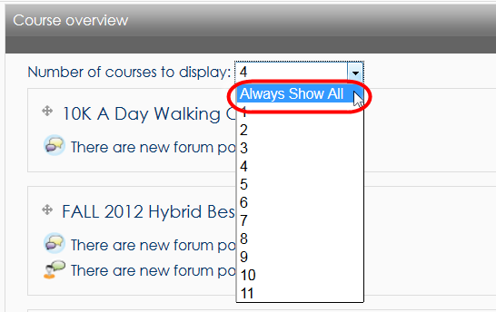
- Left-click the icon, and drag a course to the top of your list. (You may have to click and drag a number of times to move the class all the way up the page.)  - You’ll want to drag the current semester’s course to the top of the list. | 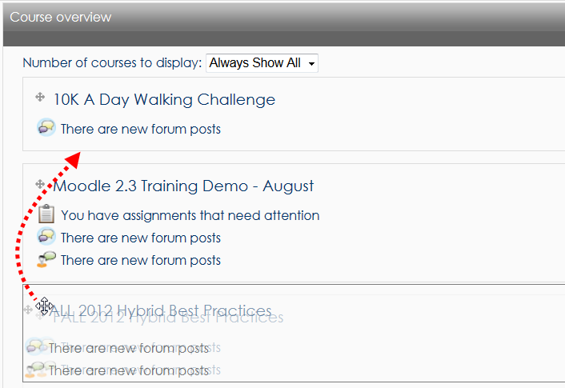
- Once you’ve finished dragging your courses to the top of the list, select the number of courses you would like Moodle to display.  For example, if you are taking/teaching four courses this semester, and you dragged those four courses to the top of the list, select 4 in the Number of Courses to Display field. Then only the top four courses will display. The rest of your courses will be temporarily hidden from view in the Course Overview block. | 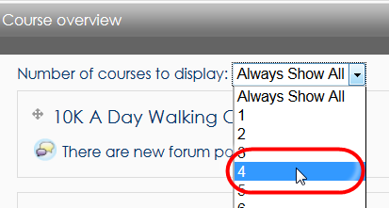

Viewing Assignments and Forums in the Course Overview Block
Task | Screen Shot
In addition to displaying your current courses, the Course Overview block displays information about assignments and forums.  - Click the new Forum Posts icons and Announcements icons to view what people have posted since the last time you opened the forum. The new posts will appear in yellow.  - Ignore the You Have New Assignments  icon 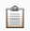. It is unreliable for both student and faculty use. These icons do not accurately indicate when an assignment needs attention. Ignore them. Students should go to a class and click on an assignment to determine its due date and get feedback. | 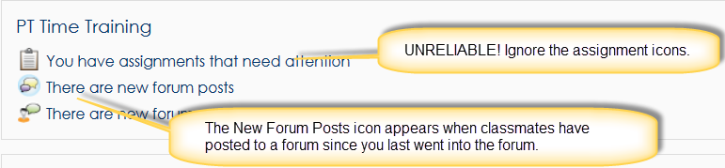

Navigating in Your Moodle Class
Refer to the picture below for information about navigating in Moodle. Click here for a video on navigating new Moodle.

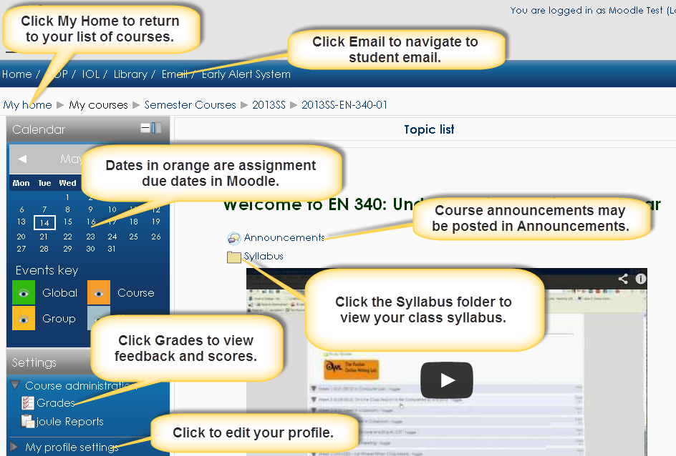

Using Blocks
Blocks are located in the right and left columns of your course. They provide additional information about elements of your course.

Docking Blocks –You can move blocks to an area on the left of the page that Moodle calls the Dock. You may wish to temporarily dock all of your blocks to gain more screen space for the course content. When you dock a block, it remains docked even after you log out of Moodle and log back in. Click here for a video on working with blocks.

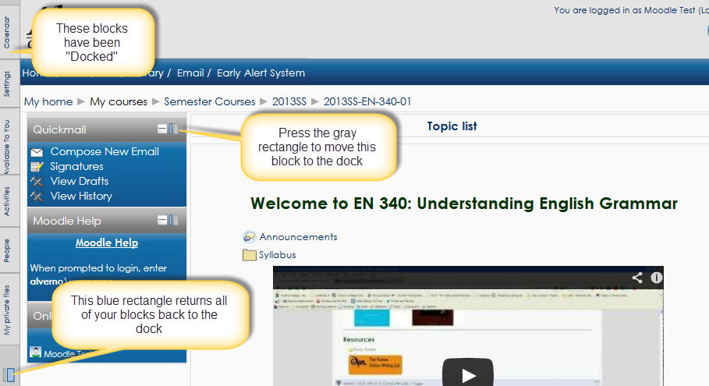

Block | Function
Calendar Block  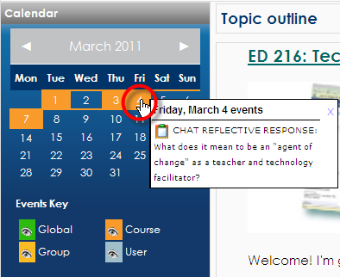 | - Dates highlighted in orange mean that something is scheduled for your class on that date. For example, a class assignment is due on that date.  - Hold your cursor over a date highlighted in orange to see a popup with an overview of the scheduled event.  - Click on the date to view a detailed description of the scheduled event.
Settings Block  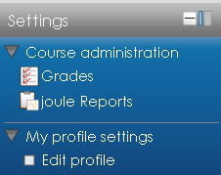 | Grades  - Click the Grades link to view scores and feedback on assignments from your instructor.  Joule Reports  - Click the Joule Reports link to run a report on your activity in the class.  My Profile Settings  - Click Edit Profile to make changes to your Moodle profile. Optionally add your picture and information yourself. You set up one profile, and this profile identifies you in all your Moodle classes.
Attendance Block  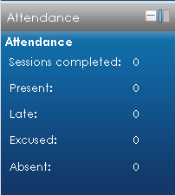 | - If your instructor is using Moodle to take attendance for the class, a summary of your attendance statistics will appear in this block.
Courses Available to You Block  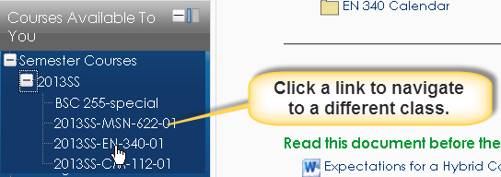 | The Courses Available to You block lists all classes you are registered for.  - Click the + to the left of each folder to expand the category. Classes are categorized by semester.  - Click the name of a course to go to the course.
Activities Block  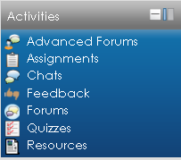 | Provides a clickable link to all the elements of the class your instructor created. The following is a list of the most common activities you may encounter.  - Advanced Forums/Forums - A list of all discussion groups in the class.  - Assignments – A list of all assignments for the class.  - Attendances – Your attendance records (if your instructor is taking attendance in Moodle.)  - Chats – A list of online chats in your class.  - Choices – A list of polls in your class.  - Feedback – A list of longer surveys in your class.  - Lessons – A list of multi-page documents created in Moodle.  - Quizzes – A list of all quizzes in the class.  - Resources – A list of files, folders, links to webpages, etc., your instructor posted on the front page of the course.
Quickmail Block  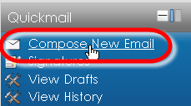 | Quickmail is Moodle’s email client.  - Click Compose Email link to compose an email. You can send an email to the instructor or one or more students in your class.  - Quickmail only sends email. You do not receive email through Moodle. Moodle emails are always delivered to your student email account. For example, if your instructor sends you an email through Moodle, you will receive it in your student email account. If you reply to your instructor, your reply email will be sent to her Alverno email account, not Moodle.  - To access your student email account, click the Email > Student Email at the top of the page.  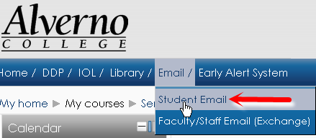
People Block  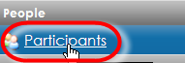 | - Click the Participants link to view a list of your classmates.  - You can click names of students to view their profiles.

Configuring Your Profile
Your Moodle profile has a place for your picture and information about you. You set up one profile, and this profile identifies you in all your Moodle classes. Click here for a video on updating your profile.

IMPORTANT: Everyone in Alverno’s Moodle system can view your profile, so please make sure the picture you upload and the information you enter adhere to Alverno’s Student Handbook and technology use policies.

Task | Screen shot
- Click My Profile Settings > Edit Profile in the Settings block. | 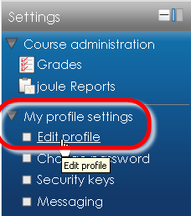
- Type information about yourself in the Description field. | 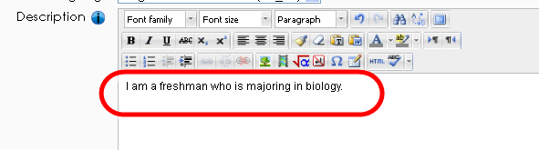
- Drag a picture of yourself into the New Picture window.  Note: The maximum picture size is 500mb, but we encourage you to reduce your file size well below that limit. Use Photoshop or a free online utility like http://www.myimagenie.com/ or http://www.aviary.com/online/image-editor# to reduce the size of your file. | 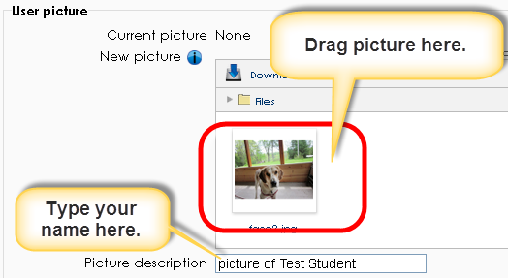
- In your Moodle profile, type your interests. Separate each interest with a comma; this will turn each of your interests into a link that will connect you with other Alverno students and faculty who share your interest. | 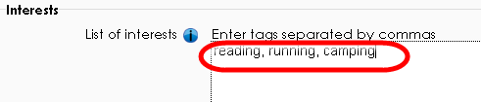
- Click the Update Profile button. This saves your changes to your profile.  Note: You can always go back and change your profile at a later time. | 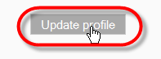

Submitting an Assignment
Do the following to upload an assignment file to Moodle. Click here for a video on Moodle assignments.

Task | Screen shot
- To enter a class, go to the Moodle home page, and click the link of a course in the Courses Available to You block (on the right side of the page).

- Once you are in your course, locate your assignments in the center column of the page.  Note: Assignments can be identified by the  clipboard icon. | 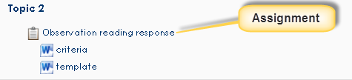
- Make sure to look for templates or criteria sheets above or below the assignment.  Important: Save Word documents to your computer or flash drive before making changes to the file. | 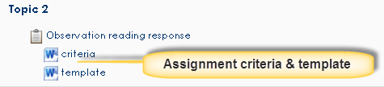
- To open the assignment, click the assignment’s link. | 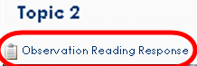
- Review the following parts of the assignment:  - The assignment’s criteria  - The assignment’s due date | 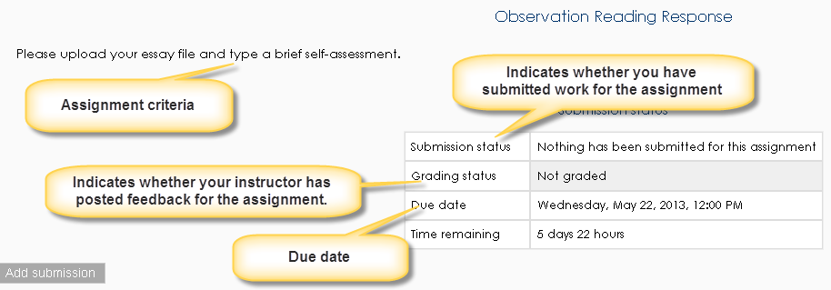
- To submit your work for an assignment, scroll down, and click the Add Submission button.  Note: Depending on how your instructor configures the assignment, you may not be able to upload your file to the assignment if its due date has passed. | 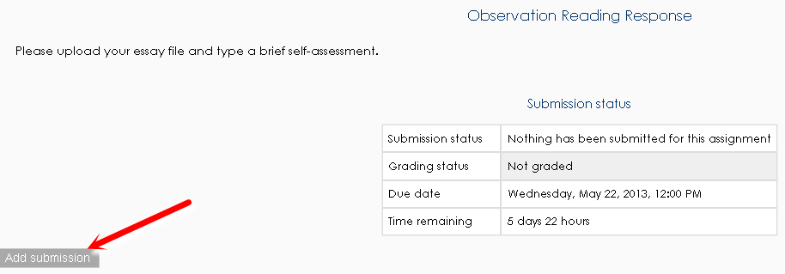
- Do the following:  - If the Online Text box appears – Type your assignment directly into the box.  - If the File Submissions box appears – Upload your file to the assignment by dragging and dropping the file into the box or by clicking the button. | 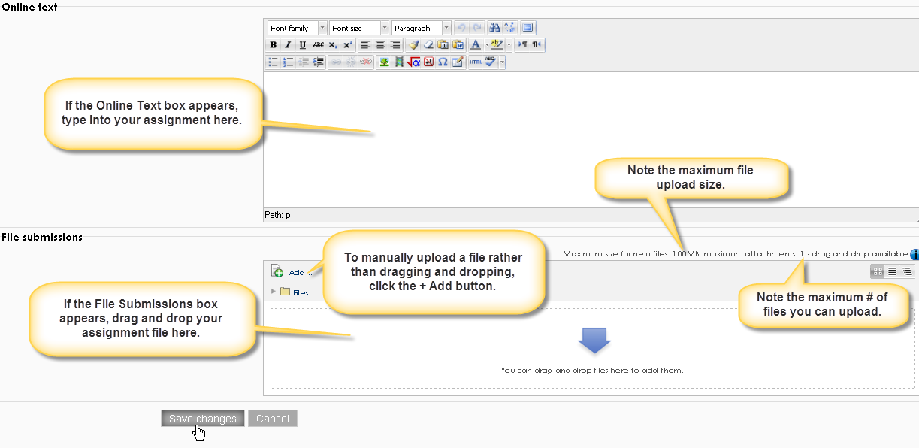
- Click the Save Changes button. | 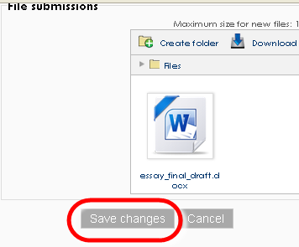
- Note the following fields:  - Submission status – When you submit your work, this field will be green or yellow:  - Green - “Submitted for Grading” – This means your file has been submitted to your instructor.  - Yellow “Draft (Not Submitted)” – This means your assignment is not yet submitted to your instructor. Click the Submit Assignment button at the bottom left of the page to turn the assignment in.  - Grading Status – This field will say, “Not Graded” until your instructor uploads feedback to you.  - Online Text – This contains the text you typed into Moodle for the assignment (if this was part of your submission).  - File submissions – This contains the file you uploaded to the assignment.  Important: Click the Edit My Submission button if you need to change your assignment submission. | 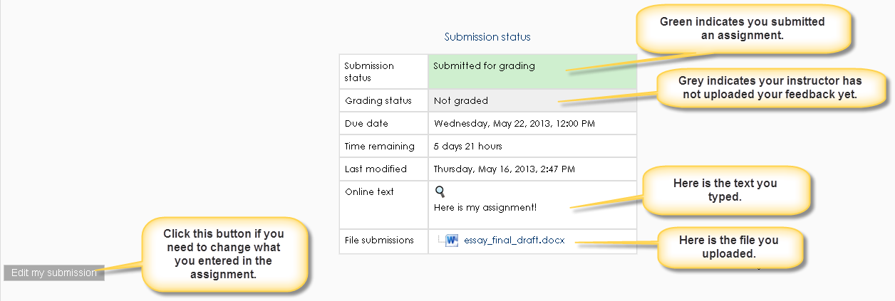
- After your instructor assesses your work, you can click on the assignment to see your feedback.
- Scroll down to view your feedback.  - Grade - A letter from a scale (e.g., Satisfactory, Unsatisfactory, In Process)  - Graded On – Date/time your instructor gave you feedback.  - Graded by – The name of the instructor who gave you feedback.  - Feedback comments – Feedback your instructor typed directly into Moodle.  - Feedback Files – Feedback in a Word document or other file your instructor uploaded to the assignment. | 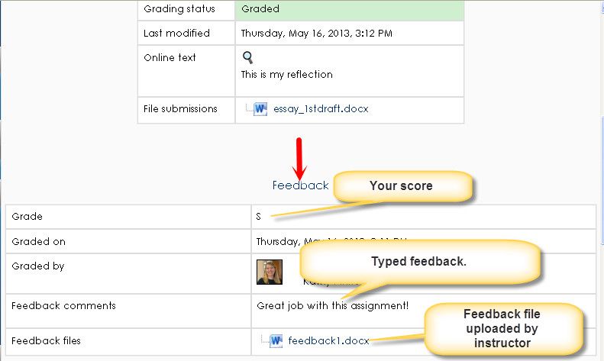
- An alternate way to view your feedback is to click the Grades link in the Settings block.

- From this screen, you can view your scores and feedback your instructor typed into Moodle, but you cannot view feedback your instructor uploaded in file form.  Note: If you want to see file feedback (such as Word documents your instructor uploaded), click the name of the assignment in gradebook to enter the assignment, and scroll to the bottom of the page. | 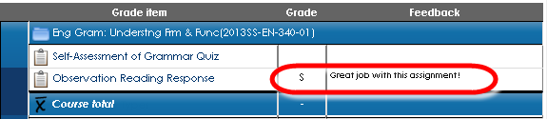

Participating in a Discussion Group (Advanced Forum)
Discussion groups are called advanced forums or forums in Moodle. Do the following to participate in a discussion group/advanced forum in Moodle. Click here for a video on forums in Moodle.

Task | Screen shot
- Click the discussion group’s name to enter the discussion group.  Discussion groups can be identified by the person talking icon. | 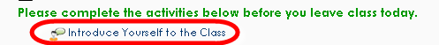
- Depending on how the forum is configured, you may do the following:  - To start a new discussion topic - Click the Add a New Discussion Topic button.  - To reply to an existing post - Read the post and click the Reply link. | 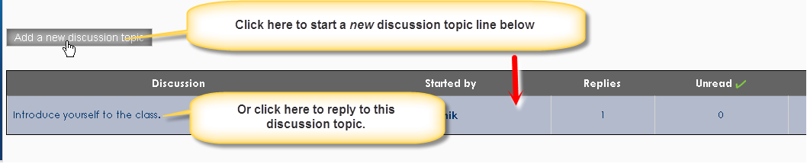  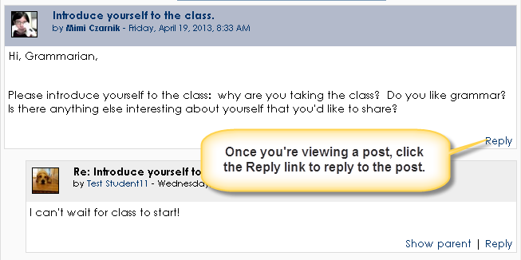
- Type your reply in the Message area.  - To attach a file to your post, drag and drop a file into the Attachment area. (Optional)  - Click the Post to Forum button.  Note: You have 15 minutes to edit your response. After that, the response can’t be edited. | 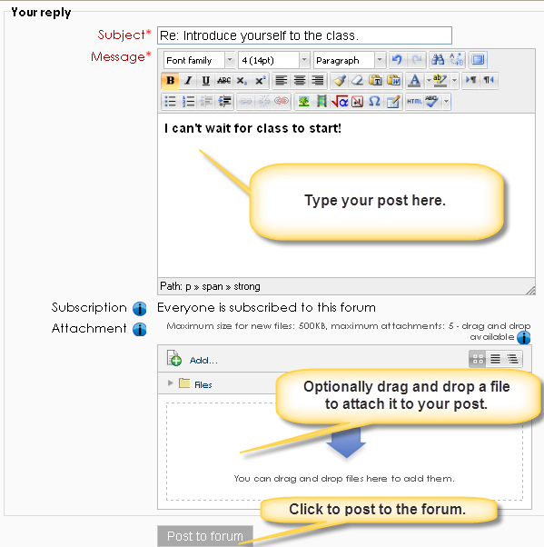
- If your instructor provides feedback on your discussion group participation, you can view your feedback by clicking the Grades link in the Settings block.

- From the gradebook, you can see the letter you received and the feedback on your discussion group.  - Click on the name of the discussion group to view your feedback in greater detail. | 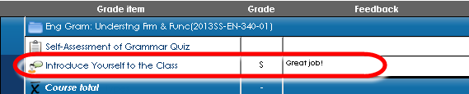

Getting Help
For technical assistance with Moodle, contact:

- A lab assistant in the Computer Center (414) 382-6336 – Lab assistants are available when the Computer Center is open.
- The Help Desk - Help Desk submissions will be picked up at 8 a.m., 10 a.m., noon, 2 p.m. and 4 p.m. All requests submitted after 4 p.m. will be received the next day at 8 a.m. The Help Desk is covered Monday-Friday only. There is no weekend or holiday coverage.
- Moodle Help block – There is a Moodle Help block located in the lower left column of each Moodle course. Click the Moodle Help link to submit your Moodle question to the helpdesk. This will link directly to Averno’s help desk system. To sign in, type alverno\username.
- Click here for a detailed video about how to use the new help system in Moodle.
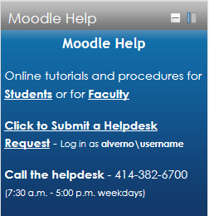 | 