Recovering your LiveText Password

Your LiveText username and password are not synchronized with your Alverno password. In most instances, you will be accessing LiveText using a link in Moodle. If you forget your LiveText username and or password, these instructions will help you gain access to your LiveText account.
Task | Screen Shot
Open Firefox and navigate to www.LiveText.com.  - Click on the Login link in the upper right hand corner of the screen.  - Click Forgot Password. | 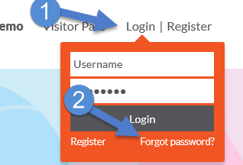
- Type your Alverno email address in the text window, and click Continue. | 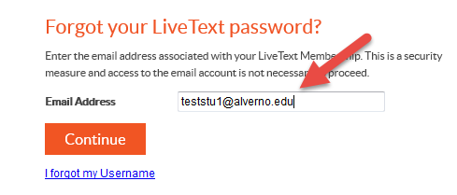
- Click the top option to have LiveText send an email to your Alverno email.  - Click continue. | 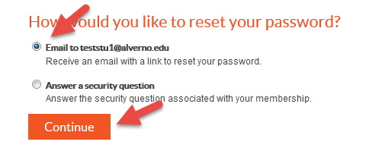
- Open your Alverno email, and look for an email from support@livetext.com. The email will remind you of your LiveText username.  - Click one of the links in the email and you will be taken to the Reset Your Password screen. | 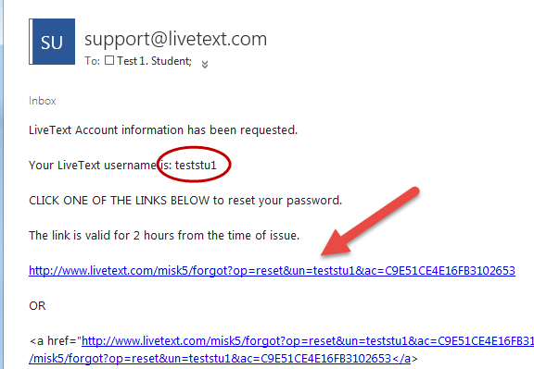
- Enter your new password twice, and click Continue. | 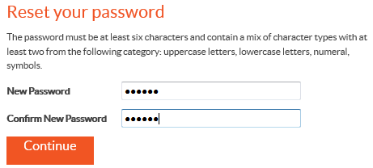
- You will receive a message confirming that your password has been reset and a link to access your LiveText account.  Note: the first time that you click on a LiveText link in Moodle, you will be asked to enter your LiveText username and password. | 