Download Student Work and Feedback from Moodle
Instructors have expressed an interest in easy ways to extract student work from Moodle for narratives or student portfolios. Moodle has several tools that make it easy to download student work. All files uploaded to an assignment can be downloaded at once using the “Download all submissions” grading action. Instructors can also download online text assignments and feedback using the “Download Grading Worksheet” feature.

Task | Screen Shot
Download all Submissions  - Enter assignment  - From the settings block, select “Download all Submissions.” The resulting zip file will contain all of the student work uploaded to the assignment | 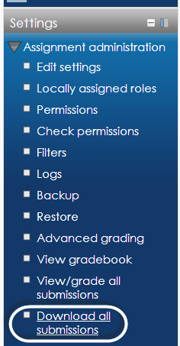
This same functionality can be accessed from within the assignment.  - Click on the assignment.  - Click View Grade all Submissions.  - Make sure Visible Groups is set to All Participants | 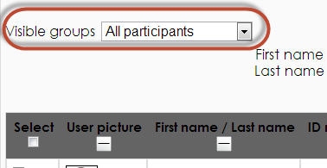
- Set the Grading Action to Download All Submissions. | 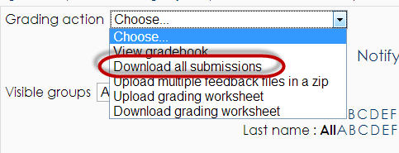
To download student online text assignments and instructor text feedback do the following:  - When configuring the assignment, change” Offline Grading Worksheet” to Yes under” Feedback Settings.” | 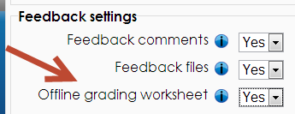
After students have submitted work.  - Enter the assignment.  - Click “View Grade all Submissions.”  - Make sure Visible Groups is set to All Participants  - Select Download grading worksheet.  - Grade information, including online text and online feedback is downloaded to an excel spreadsheet. | 