How to Self-Enroll in the “Alverno IRB Researcher Training”
(If you are not already enrolled in IRB training through a course)

- Log into your Moodle Account
- Look in the left-hand column under the tab titled “Navigation” and click “Site Home”

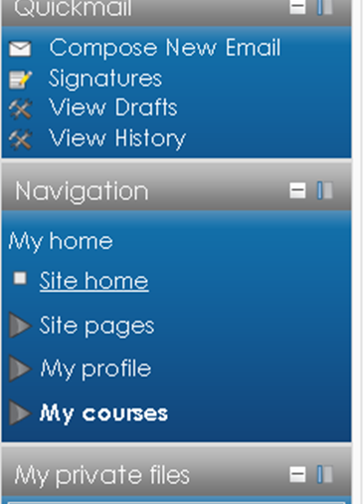

- Scroll to the bottom of the page where you will find the “Search courses” box
- Type in “Alverno IRB Researcher Training” and click “Go”

- Click the course name

- Find the “enroll me” button and click to self-enroll

- You will be introduced to the “Alverno IRB Researcher Training” course page and now have access to begin training to become a certified IRB Researcher

Congratulations you are now signed up for the IRB Training!

