Printing Quota FAQ
Question/Answer | Screen Shot
- What is your printing quota?
Registered students each receive 400 print pages per semester (fall, spring, and summer). All black and white campus printers are set up to print on both sides of the paper (duplex) by default; however, you can specify that any job print on only one side of the paper (simplex) if necessary. Since we only charge one page for each piece of paper printed, printing duplex effectively doubles your print quota to 800 pages per semester! Printing done on Alverno’s campus printers is tracked and logged by a program called PaperCut.
- Why do we have a printing quota?
A printing committee met a few years ago to look at the rising costs of printing. This committee reviewed the amount of printing the average student does, along with printing policies at other colleges. After much deliberation and concern for additional costs to students, the printing committee decided that we needed a printing policy. This policy was reviewed and approved by Alverno’s Technology Steering Committee.
- Why is the quota 400 pages?
When the committee looked at printing logs, they found that 85-90% of Alverno students printed less than 400 pages each semester, and over half the students printed less than 100 pages. Our department periodically reviews printing logs to determine if the current quota still meets the needs of most students.
- How do I check my print balance?  To check your print balance, double-click the green PaperCut icon (in the system tray on the far right of the task bar) | 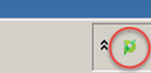
- A window will appear showing your current balance. | 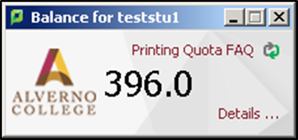
- You may also just hover your mouse over the PaperCut icon to see your balance. | 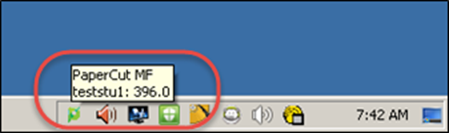
- What if I am using a Mac computer?  When you first login on a Mac (Apple) computer, PaperCut will start automatically and the balance window will open. You can close this window by clicking on the small red button in the upper left hand corner of this window. | 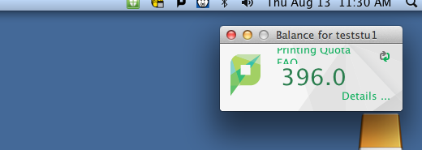
- If you wish to see the window again, simply click once on the PaperCut icon located in the upper right hand corner of the Finder bar.

- How do I know when my balance is getting low?  When your print balance is 75 pages or less, a window will pop up every time you print and/or login to alert you to your current print balance. | 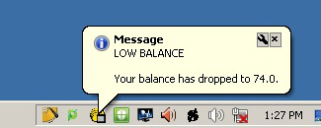

- What happens when my print balance gets down to zero?
When you try to send a print job, you’ll get a message that you don’t have enough credit to print. PaperCut will deny your print job until you purchase more print pages.
- How do I purchase additional print pages?
You may purchase additional print pages at 10¢ a page (black & white) from lab assistants or professional staff in the Computer Center, the Library, or the Media Hub. The minimum purchase is $5.00. Any additional print pages that you purchase are valid only through the end of the current semester. The expiration date for print pages is posted on the Technology Services home page and will be added to your receipt when pages are purchased. Print pages cannot be transferred or carried over to the next semester.
- What happens to my printing balance at the end of the semester?
All print balances left at the end of the semester are erased when the quotas are reset for the next semester.
Quotas are reset by Technology Services staff three times a year.
- In January, on the Monday before Alverno on the Weekend begins.
- In May, on the Monday after Graduation.
- In August, on the Monday before Alverno on the Weekend begins.
When new print pages are added, the expiration date will be posted on the home page of the Tech Services website. Printing balances may not be transferred or carried over to the next semester.
- How does the printing quota apply to the color laser printers in the Media Hub Lab and in the Computer Center?
Each page printed on the color laser printers counts as ten (10) black & white pages and costs $1.00. If your print balance is 400 pages and you print one (1) page on the color printer, your new balance will be 390 pages.
- What other kind of information is available to me when I login to PaperCut?  In the Paperclient window, you can click on Details…, which will direct you to a webpage where you can login to PaperCut. | 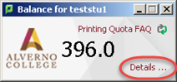
- When prompted, enter your network username and password. | 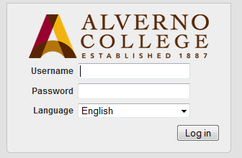
- Now you will see your PaperCut homepage. From here you can view your:  - Transaction (Print) History  - Recent Print Jobs  - Jobs Pending Release. | 