Working With Crosslisted (Xlist) Courses

What Is a Crosslisted Course?
A crosslisted course is a course that is offered for registration under two or more departments. Typically, the classes are taught at the same time, by the same instructor, and they share a common XList class in Moodle.

In Moodle, when courses are crosslisted, you have blank “child” courses that feed into an XList course. The only function of the child courses associated with the XList course is to feed their lists of registered students into the XList course. Instructors never add content to child courses; they only add course content to the XList course. Students do not see the child courses; they only see the XList course.

The following screen capture illustrates how a crosslisted course and its child courses appear in Moodle.

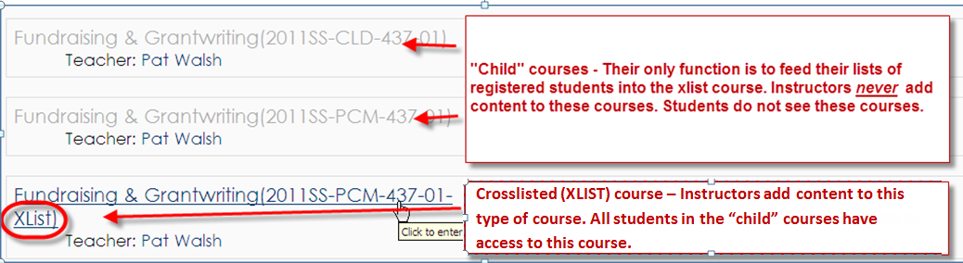

How Do I Crosslist a Course?
You must contact the Registrar’s Office if you would like to have courses crosslisted. For courses to be eligible for crosslisting, the Registrar requires that the classes be taught at the same date and time. If the Registrar approves the crosslisting of your courses, the courses will then be crosslisted in Datatel, and that information will transfer to Moodle within 24 hours of the change. If you had already added course materials to any of the child courses, you will need to move it to the XList course in order for your students to access it.

How do I Add a TA, Co-Instructor, etc. to a Crosslisted Course?
You cannot directly add someone to an XList class. You can only add a person to a crosslisted class through one of the class’ child courses. The only reason an instructor would enter a child course is to add someone to the XList class in one of the following roles:
- Co-instructor
- Non-editing teacher
- View only
- Collaborator without email
- Collaborator with email
Note: Students should always register for a class through Datatel. You should not add a student to your class through Moodle.

