Creating a Book Resource in Moodle

A book in Moodle is a multi-page document that can contain text, links, and multimedia elements such as pictures and video.

Task | Screen Shot
- Log into Moodle and go into the course.  - Click the Turn Editing On button.  - Go to the topic where you want to add the book, and click the Add and Activity or Resource button. | 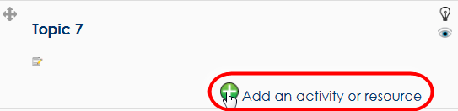
- In the Resources list, select Book.  - Click the Add button. | 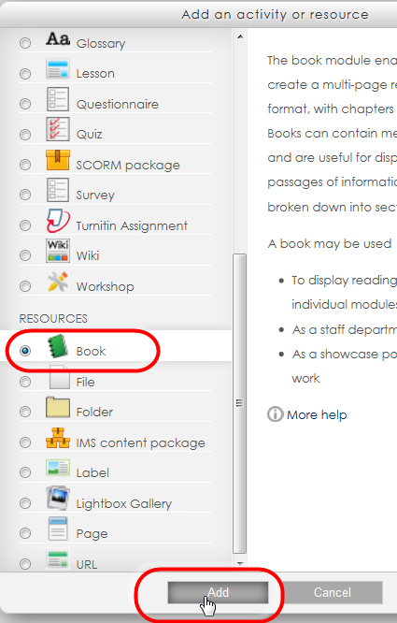
The book settings page opens.  - Fill out the fields as follows:  - Name – Title of your book  - Description – Description of your book for your class.  - Leave all other fields as-is. | 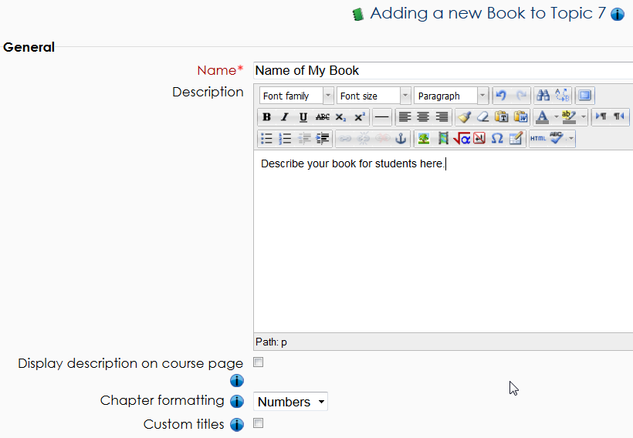
- Click the Save and Display button. | 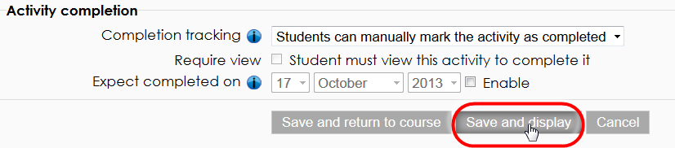
Now you can add the first page to your book.  - In the Chapter Title field, type the name of the first page in your book.  - In the Content field, add text, pictures, videos, etc.  - Click the Save Changes button. | 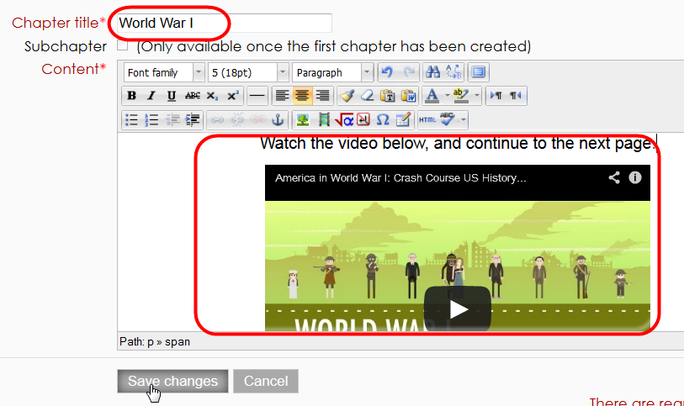
The page appears in your book.  - Note the title of the page appears in the Table of Contents block in the left column. | 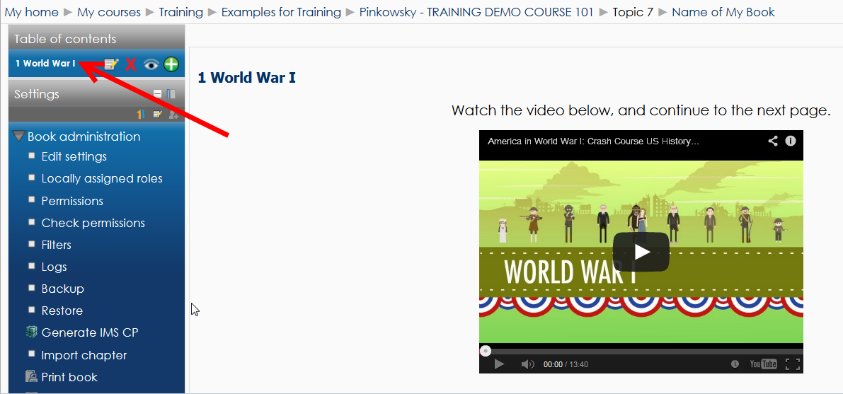
- In the Table of Contents block, click the + icon to add another page to your book. | 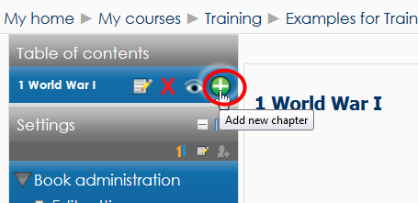
- Repeat steps 9 through 13 until you have added all the pages to your book.
- Use the icons in the Table of Contents block to change page order, edit page contents, delete the page, hide the page from students, or add another page to your book. | 