Creating Advanced Forums-Graded

In Moodle, online discussion groups are called advanced forums. With advanced forums, you can facilitate online discussion between students. You can post a question and have students respond to it. Students can respond to each other’s posts, too. People can upload files with their advanced forum posts, so you can even create an advanced forum where students post their work and other students respond to it with their comments.

Do the following to create an advanced forum in Moodle that is graded. In other words, you will assign a score to students’ forum posts in Moodle.

Task | Screen Shot
- Open your Moodle course.
- Click the Turn Editing On button in the top right corner.
- Go to the topic where you want to insert the advanced forum.
- Click the green circle with the plus sign.
- Select Advanced Forum. | 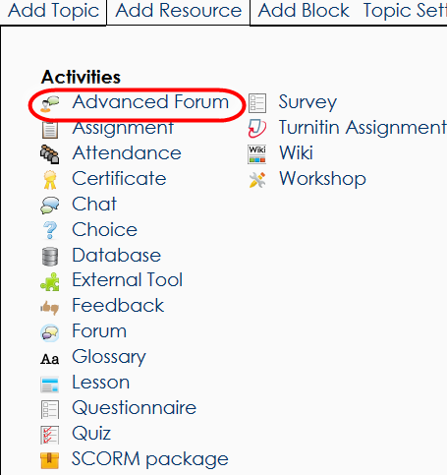
- In the Forum Name field, type the name of your discussion group. | 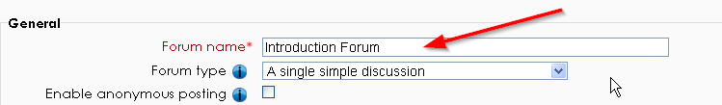
- Do one of the following:  - If you want students’ forum posts to appear on a single page, select Single Simple Discussion in the Forum Type field.  - If you want to create a multi-threaded discussion where students’ posts appear on separate pages, select Standard Forum for general use. | 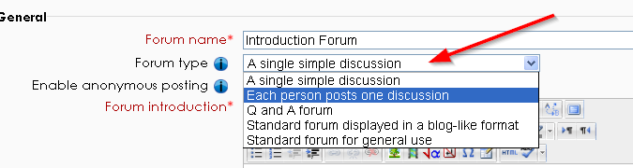
- For anonymous posts, select Enable Anonymous Posting. | 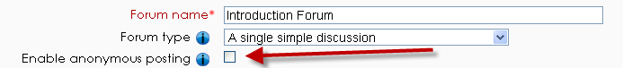
- In the Forum Introduction field, type directions for your students to follow. Remember that posts can include pictures, videos, and links. | 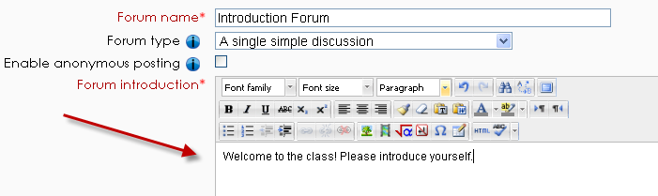
- Set your subscription mode settings to determine whether each participant in the class receives an email when someone posts to the forum.  - Optional subscription – Each participant can choose whether to get an email every time someone posts to the forum.  - Forced subscription – Participants always receive an email for each forum post and cannot unsubscribe.  - Auto subscription – Everyone gets emails initially, but users can choose to unsubscribe (opt out of forum emails) at any time.  - Subscriptions disabled – No emails are sent. | 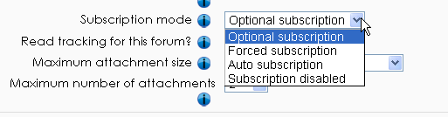
- Do the following:  - Set the Read Tracking for This Forum field to On. This setting helps students track which forum posts they have read and which they haven’t read since they last accessed the forum.  - Increase the Maximum Attachment Size field to at least 5MB if you are having students upload files to the forum. | 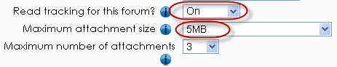
Post threshold for blocking settings control how many times a participants can post to a forum within a given period.  - If you have a problem with a student or students posting too frequently on your discussion forum, you can change these values to restrict the number of times a student can post to a forum. | 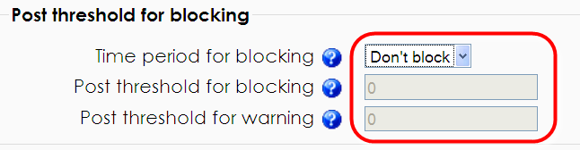
- Set the Grade Type field to Manual.  - Set the Grade field to the scale you want to use.  - Choose the desired Grading method, Simple Direct Grading is recommended. | 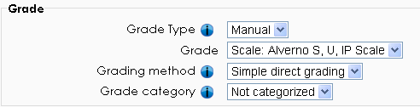
- Select Aggregate type to Average of ratings. | 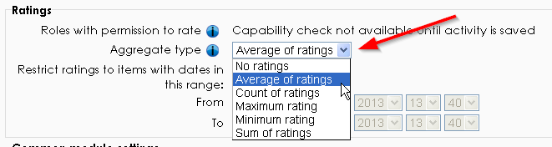
- Leave the other settings on the page as-is.  - Scroll down, and click the Save and Display button.  Your forum is ready to use. | 