Adding Links to Websites

Use the following instructions to add links to your Moodle course. You can add links to websites. If you have any questions, please contact the helpdesk at helpdesk@alverno.edu.

Task | Screen Shot
Adding URL links
- Log into your Moodle course and click the Turn editing on button in the upper right-hand corner.
- Open a new browser tab.  - Navigate to the website you want to add to your Moodle course.  - Highlight and copy the URL at the top of the website. | 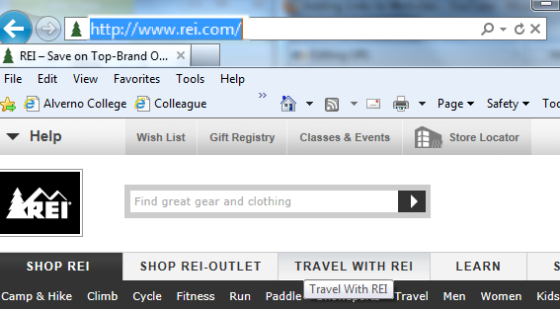
- Click back to the tab that contains your Moodle course, click into the appropriate topic and click Add an activity or resource | 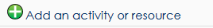

Task | Screen Shot
- Scroll down and select URL.  - Then click Add. | 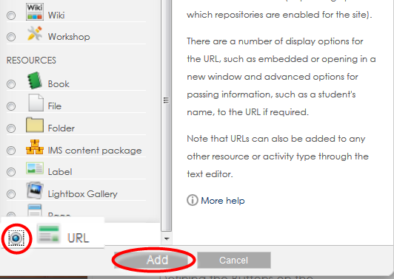
- Name the link. This is what users will see on the Moodle course.  - Paste the link in the “External URL” box | 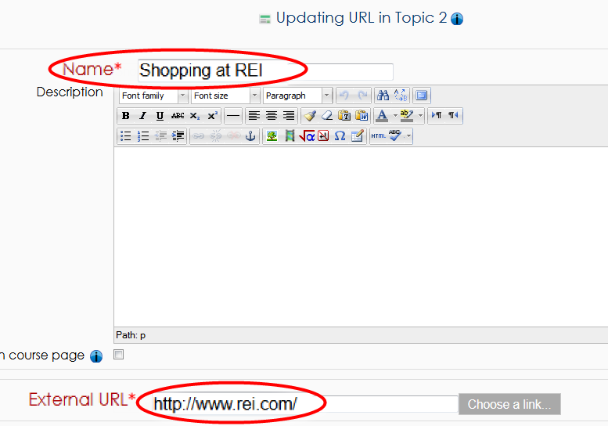

Task | Screen Shot
- Make sure the Display setting is set to display “In pop-up.”  - Scroll down and click the “Save and return to course | 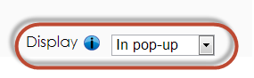  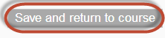
- Check the link by clicking on it in the course. | 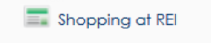
- The website will open in a popup window | 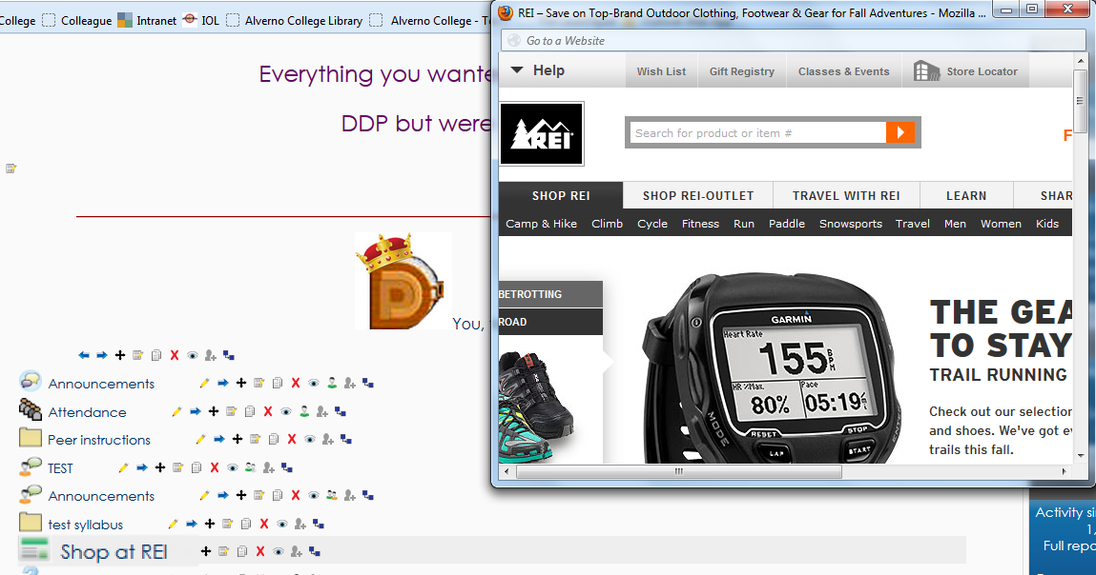

Task | Screen Shot
Adding links in a label
- Click the Add an activity or resource button.
- Because you want to link to a website from text, click Label  - Then click the Add button | 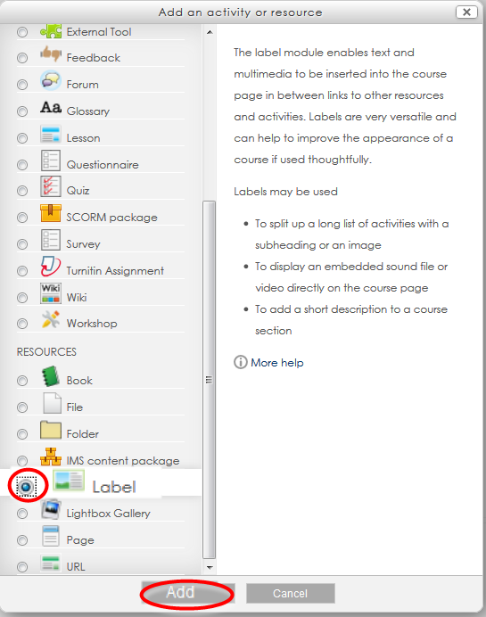

Task | Screen Shot
- In the Label text box, add text.  - Highlight the word or words to be linked.  - Click the Bold, Underline and select a dark blue font color by clicking on | 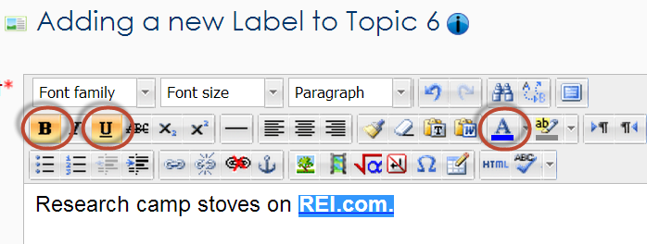
- Finally, with the words highlighted, click on the link button to attach the URL to the selected word or words | 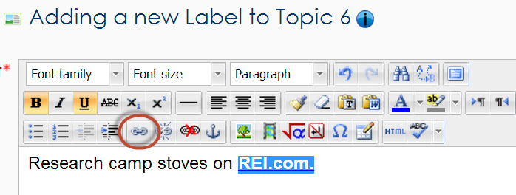
- In the popup window, paste the URL in the Link URL box  - In the Target box, select Open in new window  - In the Title box, type the website name for users with accessibility issues  - Click the Insert button | 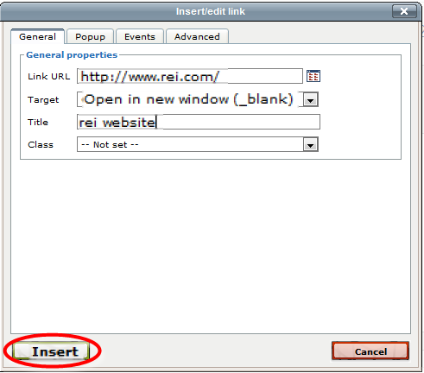
- Scroll down to the bottom the screen, and click Save and Return to Course | 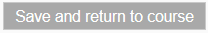

Task | Screen Shot
- On the course page you can see the URL link and the label link  - Both link to the REI website which opens in a separate window. | 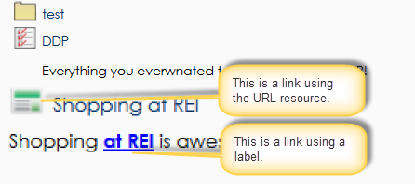

Task | Screen Shot
Linking to a video
- To link to a video turn editing on
- Browse to the YouTube video you want in your Moodle course.  - Click on Share | 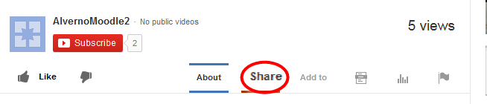
- Click on Share this video  - Highlight and copy the URL below Share this video  Note: Do not copy the URL from the top of the website | 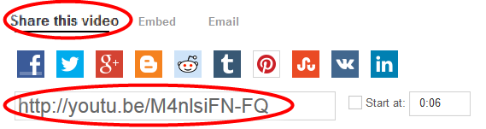
- Go back to your Moodle course and click on add an activity or resource
- Scroll down and select URL.
- Then click Add.
- Name the link (I.E. Watch this Video)  - Paste the URL in the External URL box  - Make sure the Display setting is set to display “In pop-up.” | 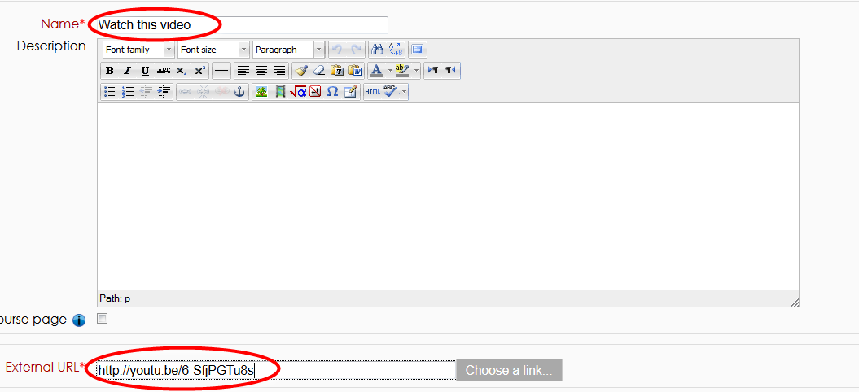
- Scroll down to the bottom the screen, and click Save and Return to Course
- The URL link will appear on you Moodle course page  - Click on the link to view the video in popup window | 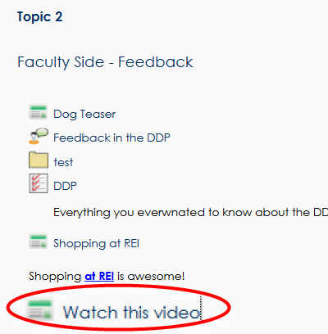

Task | Screen Shot
Embedding a video
- To embed a video in your Moodle course page, click the Turn editing on button
- Click on the Add an activity or resource button
- Select Label
- Click the Add button

Task | Screen Shot
- Go to the Youtube video  - Click on Share  - Click Embed | 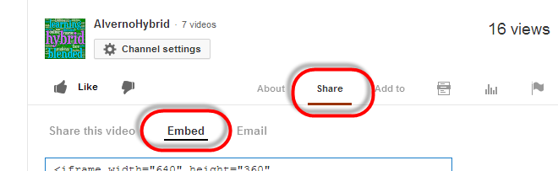
- Select the video size. 640 x 360 or smaller is recommended.  - Uncheck the box next to Show suggested videos when the video finishes | 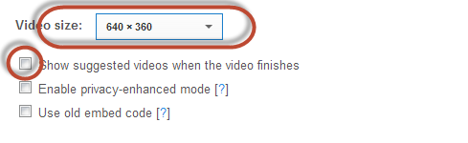
- Highlight the code and copy. | 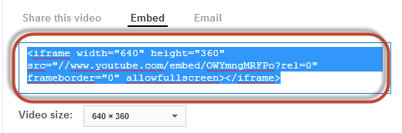
- Go back to the Moodle label.  - Click on the HTML tool | 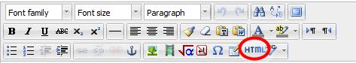
- In the HTML source editor, right click and select paste  - Scroll down and click Update | 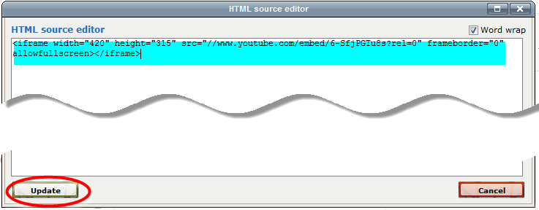
Task | Screen Shot
- In the Adding a Label screen, you can click on the centering tool center the video or leave it left justified  - Scroll down and click on Save and return to course | 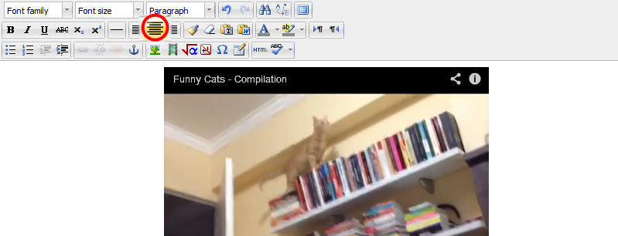
- The URL link will take up less real estate of the course page  - The embedded video can add to the interest to the page  Remember: Too many embedded videos will use up more real estate and cause students to scroll more through your activities and resources. | 