Adding Links to Resources

Use the following instructions to add resource links to your Moodle course. If you have any questions, please contact the helpdesk at helpdesk@alverno.edu.

Task | Screen Shot
Adding URL links
- Log into your Moodle course and click the Turn editing on button in the upper right-hand corner.
- Open a new browser tab.  - Navigate to the website you want to add to your Moodle course.  - Highlight and copy the URL at the top of the website. | 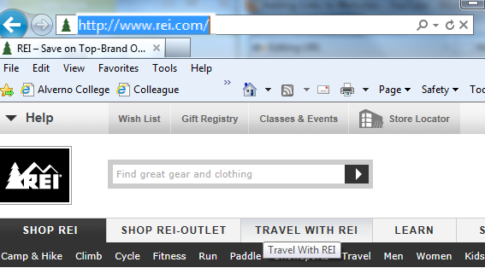
- Click back to the tab that contains your Moodle course, click into the appropriate topic and click Add an activity or resource. | 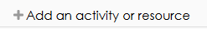

Task | Screen Shot
- Scroll down and select URL.  - Then click Add. | 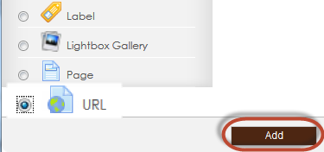
- Name the link. This is what users will see on the Moodle course.  - Paste the link in the “External URL” box. | 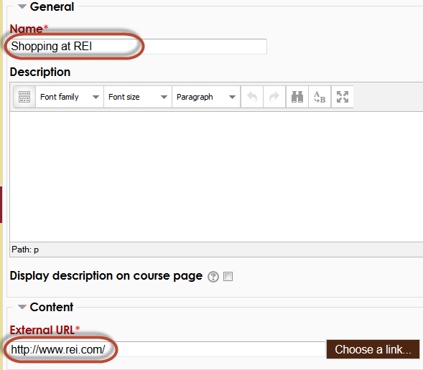

Task | Screen Shot
- Make sure the Display setting is set to display “In pop-up.”  - Scroll down and click the “Save and return to course. | 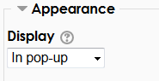
- Check the link by clicking on it in the course. | 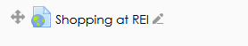
- The website will open in a popup window. | 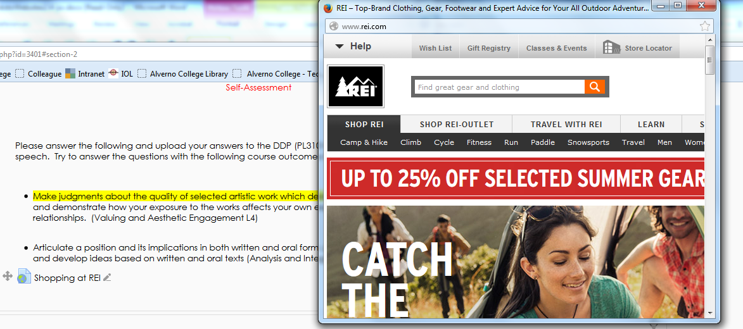

Task | Screen Shot
Adding links in a label
- Click the Add an activity or resource button.
- Because you want to link to a website from text, click Label.  - Then click the Add button. | 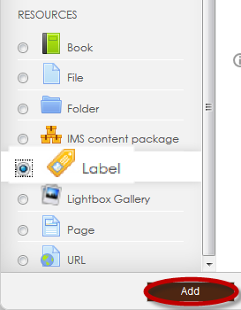

Task | Screen Shot
- In the Label text box, add text.  - Highlight the word or words to be linked.  - Click the Bold, Underline and select a dark blue font color by clicking on . | 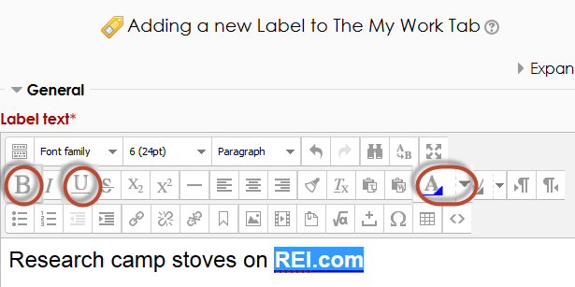
- Finally, with the words highlighted, click on the link button to attach the URL to the selected word or words. | 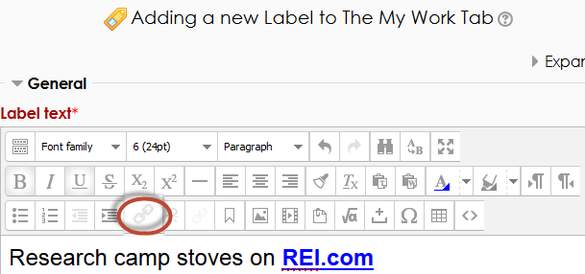
- In the popup window, paste the URL in the Link URL box.  - In the Target box, select Open in new window.  - In the Title box, type the website name for users with accessibility issues.  - Click the Insert button. | 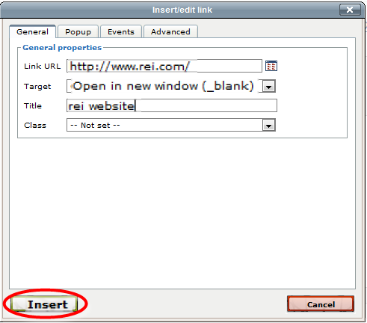
- Scroll down to the bottom the screen, and click Save and Return to Course.
- On the course page, you can see the URL link and the label link  - Both link to the REI website which opens in a separate window. | 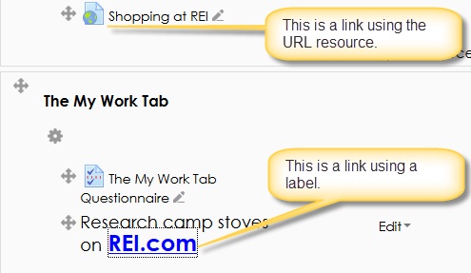

Task | Screen Shot
Linking to a video
- To link to a video, turn editing on.
- Browse to the YouTube video you want in your Moodle course.  - Click on Share. | 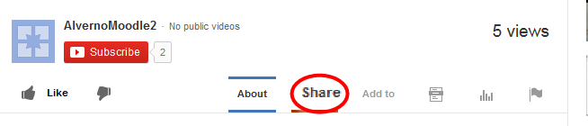
- Click on Share this video.  - Highlight and copy the URL below Share this video.  Note: Do not copy the URL from the top of the website. | 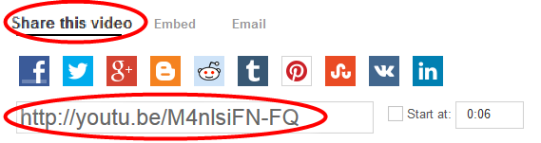
- Go back to your Moodle course and click on Add an activity or resource.
- Scroll down and select URL.
- Then click Add.
- Name the link (I.E. Watch this Video)  - Paste the URL in the External URL box  - Make sure the Display setting is set to display “In pop-up.” | 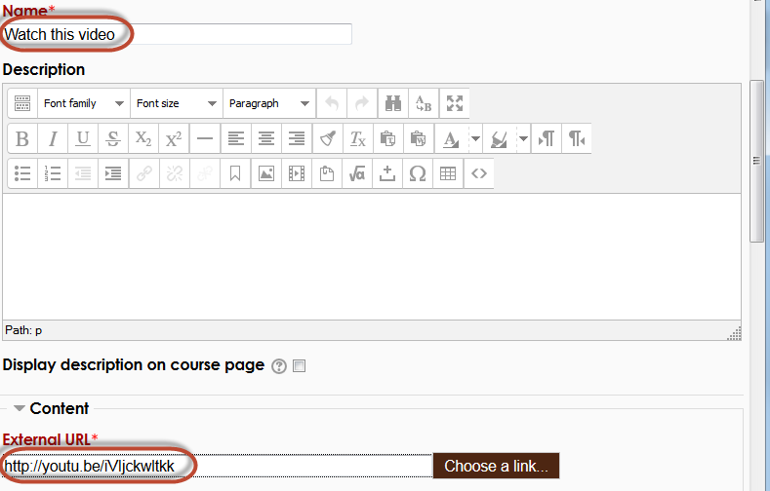
- Scroll down to the bottom the screen, and click Save and Return to Course.
- The URL link will appear on your Moodle course page.  - Click on the link to view the video in popup window. | 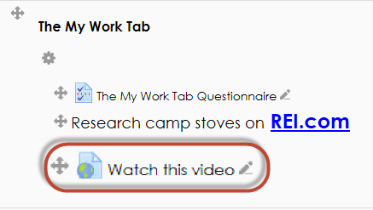

Task | Screen Shot
Embedding a video
- To embed a video in your Moodle course page, click the Turn editing on button.
- Click on the Add an activity or resource button.
- Select Label.  - Click the Add button. | 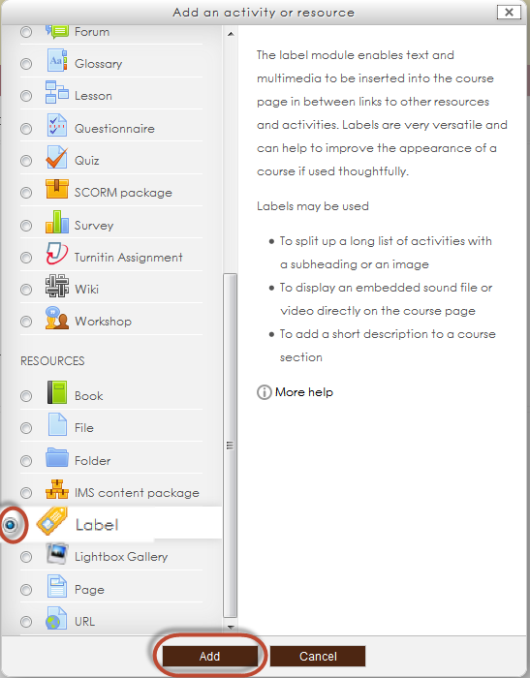

Task | Screen Shot
- Go to the Youtube video  - Click on Share  - Click Embed | 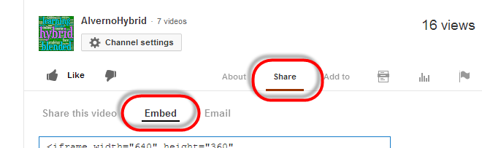
- Select the video size. 640 x 360 or smaller is recommended.  - Uncheck the box next to Show suggested videos when the video finishes | 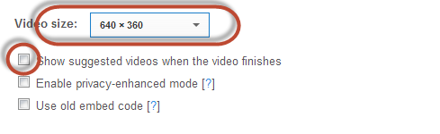
- Highlight the code and copy. | 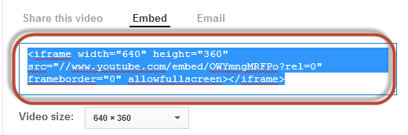
- Go back to the Moodle label.  - Click on the Toolbar Toggle button.  - Click on the HTML tool. | 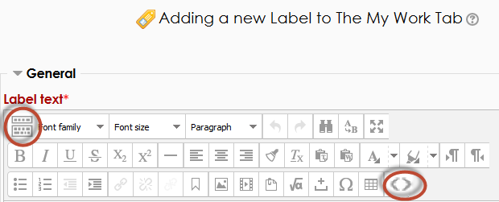
Task | Screen Shot
- In the HTML source editor, right click and select paste.  - Scroll down and click Update. | 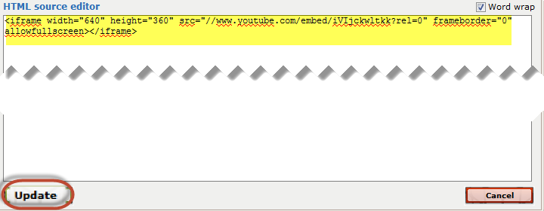
- In the Adding a Label screen, you can click on the centering tool to center the video or leave it left justified.  - Scroll down and click on the Save and return to course button. | 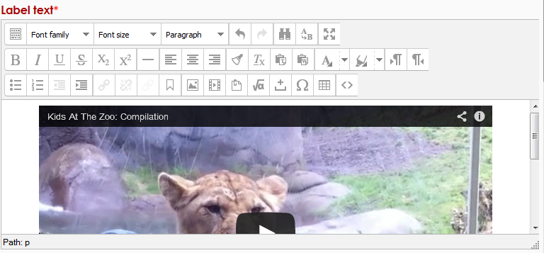

Task | Screen Shot
- The URL link will take up less real estate of the course page.
- The embedded video can add to the interest to the page. Too many embedded videos could cause a distraction to the page.

Remember: Too many embedded videos will use up more real estate and cause students to scroll more through your activities and resources.

